**5 ways to support your health and wellbeing**

**Connect . . . . . . . Be active . . . . . . . Take notice . . . . . . . Give . . . . . . . Keep learning**

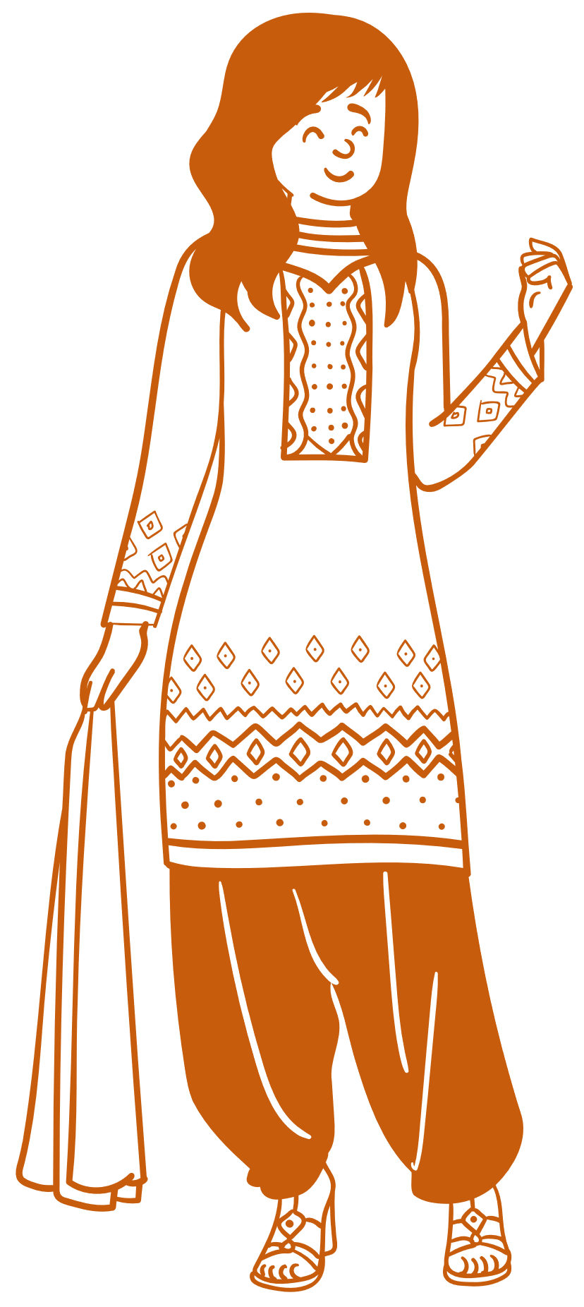

**Connect** with the people around you: family, friends, colleagues, neighbours, people at work and in the local community



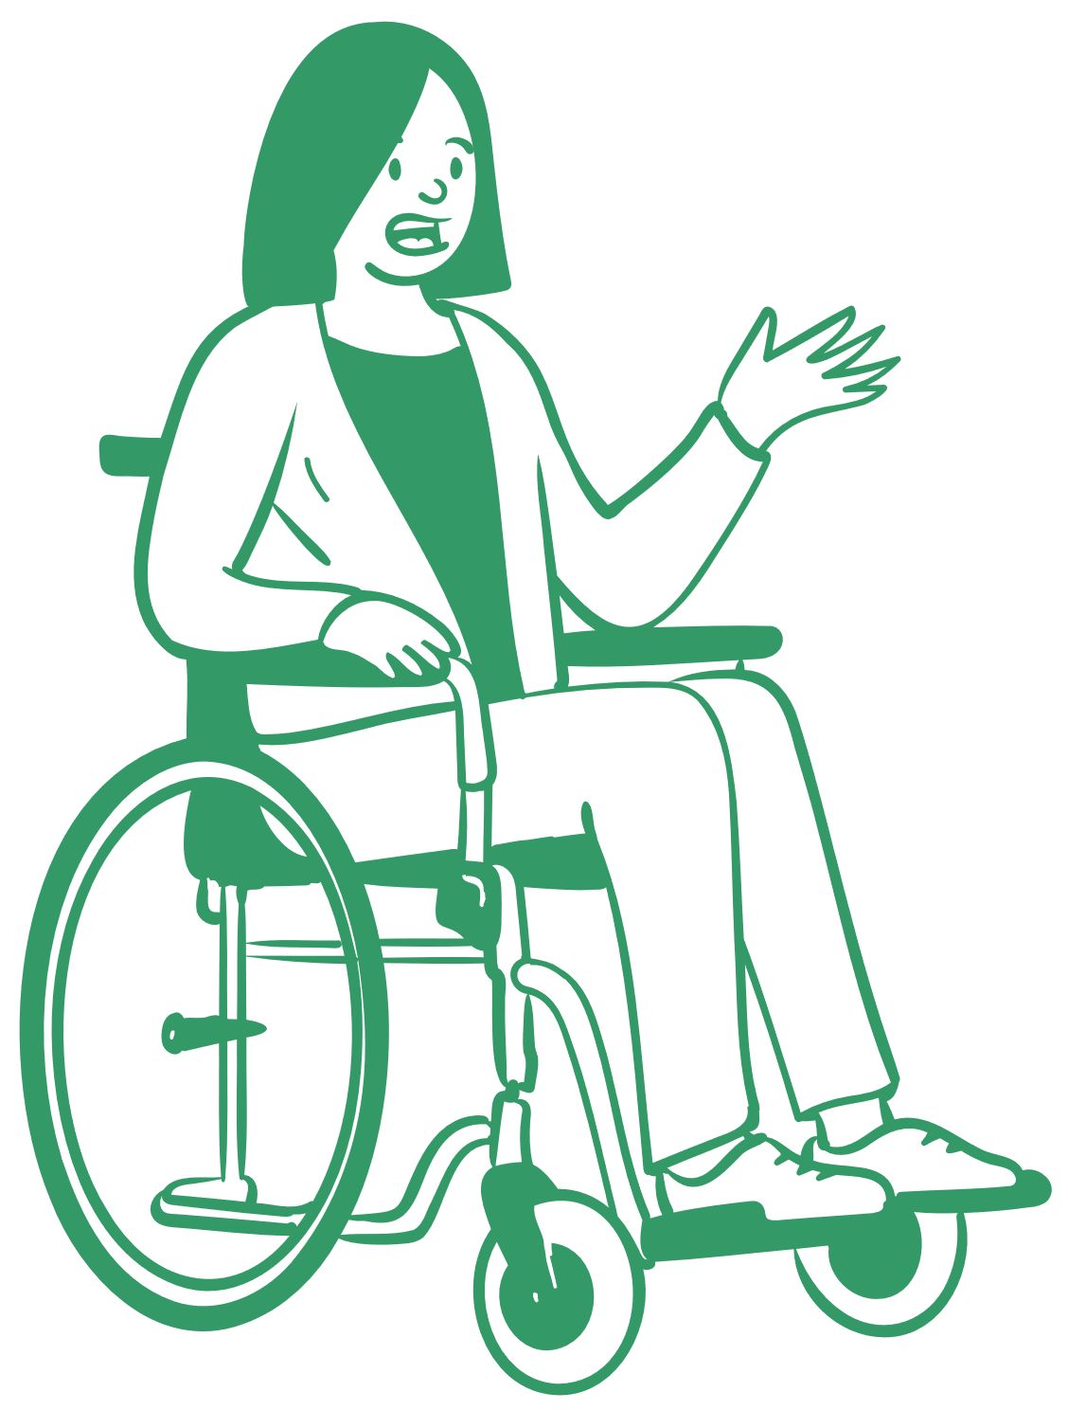**Be active** - walk… dance… exercise… But remember good quality sleep is as important to wellbeing as being active

**Take notice** - be aware of the world around you and of your own feelings. Notice the beautiful – and enjoy the moment

**Give** your time by doing something nice for a friend – or a stranger. Give someone a compliment. Contribute to a group.

learn

**Keep Learning** -try something new. As well as being fun, learning new things will help

you feel more confident.