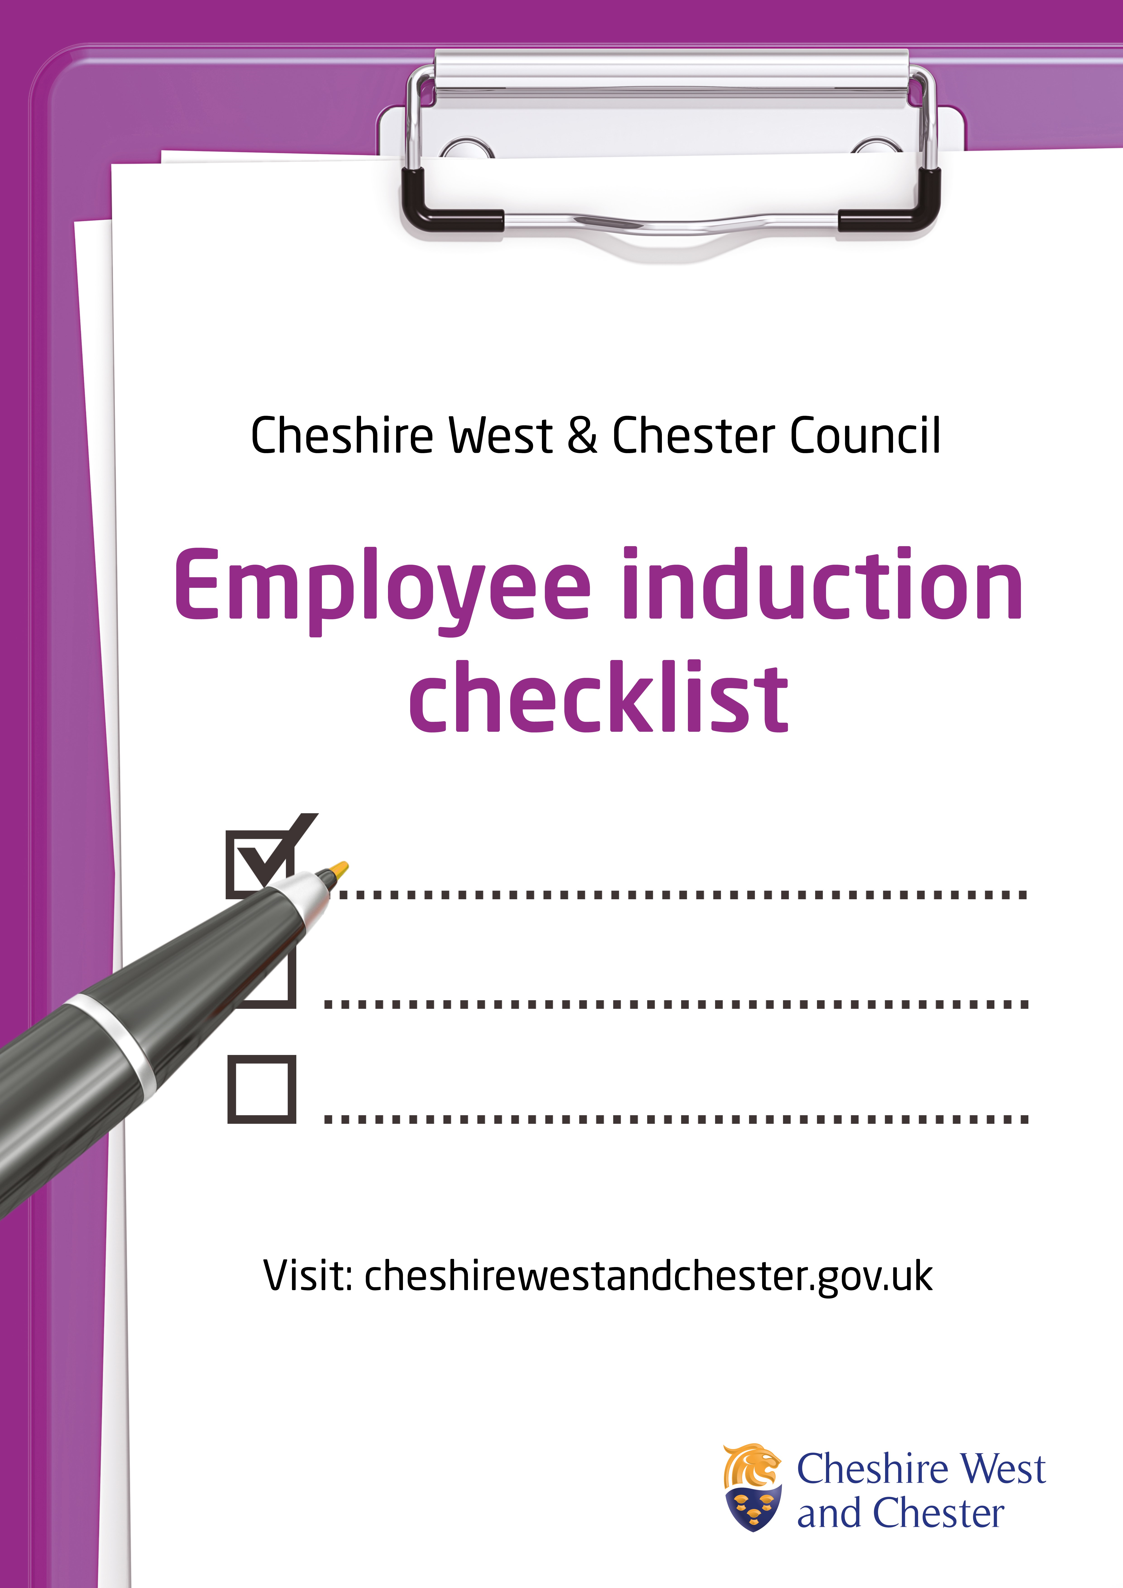
New Starter Induction Checklist
Most recent update: 9 June 2026
Colleague name
Job title
Directorate/Service
Start date
Manager name

This checklist forms part of inducting a new starter to your team and will support new employees into Cheshire West and Chester Council.
Certain parts of the induction must be completed at specific stages, and these will be reviewed with your line manager during the 2-month, 4-month and 6-month probation review meetings. It is the responsibility of the staff member to keep this record up to date. Completion of the checklist will be monitored and it is the manager’s responsibility to ensure that all applicable activities are completed.
Some colleagues may not need to complete all items on the checklist where not relevant to the job role. Services may add further items which are important as part of their specific service induction.
Induction Preparation – to be completed by recruiting manager prior to start date/  by end of Day 1 | Date completed
Prepare a personal induction programme ready for the new starters first day and week, including 1:1 meetings with relevant Managers and Senior Officers
Delegate a named person/mentor who will be assigned to new staff member to provide guidance and support during the initial weeks of employment. Name of mentor ______________________________________
Confirm that a “reasonable adjustments” conversation has taken place between the line manager and the new starter before Day 1. Any adjustments agreed have been actioned and are in place for their start date.
Advise team/colleagues of the start date of the new starter
Add to ‘whole team’ email distribution list: email Bethan Lambourne with new starter’s name and email address
Add to team structure chart: email Helen Crampton with new starter’s full name, job title, grade and line manager details

continues over
Confirm new starter has received contract of employment and terms and conditions
Confirm new starter has submitted bank details/P45 and send to relevant HR team
Arrange DBS application for relevant roles as required
Prepare the following:
- Annual leave/flexi spreadsheet
- Arrange ID badge/security fob/print card
- Stationery requirements/WFH equipment
- Laptop
- Mobile phone requirement
- Car parking pass (if required)
- Access to shared drive/specific folders/Unit 4/Learning Hub/Outlook (shared mailbox access if required)
Confirm to Bethan Lambourne:
- The name and job title of the new starter
- The date the below Right to Work checks have been completed:
  - Verification of identity
  - Verification of employment history
  - Verification of immigration and nationality status
  - Verification of criminal record (unspent convictions only)
- The date references have been received for the new starter

Day 1
Activity | Detail | Completion date | Initials
Welcome | I have been welcomed to the organisation by my manager and team.  I have been shown around the building where I am based and know where the exits, kitchen, toilets, lifts, desks and security door access are (if applicable). I know where the break areas, wellbeing and faith rooms are located.
Access to ICT equipment if applicable | I have access to the relevant IT equipment to carry out my role and have received guidance on how to access the intranet (Cheshire West Hub), MS Teams, email, shared files and where to save documents.  CWC-DigiHub - Home
Email signature | I have set up an email signature using the Skills and Employment font and layout, with appropriate logos
ICT Security | I am aware of the relevant ICT procedures and security policy and have a sound understanding of data protection regulations. I will complete the mandatory Data Protection learning within my first week: New Starter - Mandatory Learning
Learning | I have received access to my learning hub account and I understand what I need to complete as part of my induction and any specific role-based learning.  I know where to find further development opportunities and that I can discuss these with my manager: Talent and Development Hub page.
Team and Council Structure | I have been introduced to colleagues and understand how I will work with them.  I have been provided with a copy of my team structure chart, the Council Structure and  Directorate structures

continues over
Health and Safety | I am familiar with evacuation and assembly points for the Council buildings I will work in.  I am aware of:  - Evacuation responsibilities, building walk around and routes and PEEP  - Team risk assessment  - Personal Protective Equipment (PPE) (if applicable to role)  - Display Screen Equipment (DSE)  I will complete the mandatory Health & Safety learning within my first week.
Play Your Part Charter | I am aware of the Play Your Part Charter for my team which identifies the aims and priorities for my role.
Immediate Work Activities | I have an initial plan of work for the first two weeks. The plan includes time to complete the mandatory induction learning, meetings with appropriate colleagues from my team and other key contacts including support services.
Leave and Flexi Working Time | I know what my annual leave entitlement is, how to request leave and how it is approved. I am aware of the other leave options available to me.  I understand flexible working and have set up and know how to use my flexi sheet

By end of week 1
Activity | Detail | Completion date | Initials
Mandatory council induction learning | I have completed the mandatory council induction and learning in  - Cyber Security  - Fire Awareness  - Data Protection  - Introduction to Equality and Diversity  - Introduction to Health and Safety  - Safeguarding Everyone  I have booked to attend the next available Welcome event.  I confirm that I have not accessed any personal data before the completion of the Data Protection module
Safeguarding contacts | Line manager to introduce the Safeguarding Team (Lead: Matthew Smith; Deputies: Jodie Ronan, Benjamin Watts, Amy Hill) and arrange a dedicated safeguarding meeting for a later date to discuss responsibilities and procedures in more detail.
Standards of working | I am aware of the supervision arrangements, Performance Management and what is expected of me.
Modern workforce and ways of working | I understand our ways of working and the Modern Workforce principles.  I have been introduced to the Council’s “Be You” campaign, which promotes inclusion, belonging and celebrating individuality across the organisation. I understand how to access resources and where to find more information.
Absence management | I have a copy of the policy and procedures for notifying sickness and other absences. My manager has provided the relevant telephone number to contact them should I need to.

continues over
Health and Safety | I am familiar with Health and Safety procedures including:  - Fire officers for work area  - Names of first aid officers and their location  - Location of first aid box  - Accident reporting  - Desk assessment and safe working guidelines  - Security arrangements – building security, personal security, location of security buttons  - Driving on behalf of the authority policy. (age 25 and under to attend Road Skills Experience course)
Printing and photocopying arrangements | Understand where printing and photocopying facilities are located and receive your print card from your line manager.

By the end of month 1
Activity | Detail | Completion date | Initials
Code of conduct  Declaration of interests | I have read and understand the guidance on Code of Conduct and Declaration of interests  I have completed the declaration of interests and understand this needs to be completed each year: Code of conduct and declaration of interests
Social Media Policy | I have read the Social Media Policy and Guidance. I understand the standards expected of me and that any breaches of this policy may lead to disciplinary action.  I understand that I can speak to my manager if I have any queries about this policy and the standard of conduct expected.
Review Skills and Employment policies and procedures | Review the Skills and Employment policies and procedures relevant to your role.
Play Your Part Conversation | I have had a ‘mini’ Play Your Part Conversation with my manager who has explained our team’s charter and the Goals element of performance management.  I have clear goals set and agreed as part of my induction/probation. I understand that progress against these goals will be reviewed as part of probationary sign off.
Range of services | My manager has provided me with details of the services offered by the council.
Committee procedures | My manager has helped me to understand the cycle of business at the council, committees and relevant working groups, supported by Democratic Services

continues over
Links with other teams and services | I have contacted colleagues in other teams and services, started building working relationships using the right communication channels, and taken part in job-shadowing where useful. My line manager has helped set this up and supported me through the process.
Visit Skills and Employment sites | I have visit other Skills and Employment sites that I do not usually work from, to get a better understanding of the wider service and meet the teams based there. This helps build awareness of how the whole service operates and where different activities take place.
Links with outside bodies | I have contacted relevant external contacts and established initial relationship using appropriate communication channels. Supported by my line manager.
Benefits – Working Rewards | I am aware of Working Rewards, how to access these and details of other colleague benefits.
Expenses | I have been made aware of the policy for claiming expenses including; petty cash, telephone, travel and subsistence, mileage, training, protective clothing and uniform (if applicable to role).  The Unit4 microsite has a section “Claiming your own expenses” with further guidance. Enter the password Unit4 to access.
Financial Procedures | I am familiar with the financial regulations and internal procedures which apply to my role.
Understanding of Council Policies | I have been shown how to access Cheshire West and Chester Council policies and procedures. I am familiar with all People policies on the Human Resources page.
Communication Channels | I am aware of the communication channels available including team brief, and what the Communications team do.
Health and Safety | I have reviewed the Health and Safety Compliance Framework and employee checklists.

continues over
Prevent training | I have completed Prevent duty training (a requirement for everyone working within an education service, regardless of role). This training ensures I can recognise signs of vulnerability to radicalisation and understand the correct procedures for responding to concerns.
Mandatory training | Inform Bethan Lambourne of completion dates for any role related mandatory training.

By the end of month 2
Activity | Detail | Completion date | Initials
Manager mandatory learning and iManage review | If the new starter is taking on a management role, they must review the iManage resources and complete all mandatory manager training. This includes any modules required for line managers covering supervision, performance, HR responsibilities, people management and essential council processes. Their line manager should signpost them to the correct areas and ensure all required training is completed within the first 2 months.
By the end of month 3
Activity | Detail | Completion date | Initials
Play Your Part Charters and Conversations | I understand the performance management approach and have reviewed the information on the intranet.
Specific job-related training | I have discussed with my manager job related training requirements and have a plan as to how these requirements will be met.
Mandatory council induction learning | I have attended the in-person welcome event.
By the end of month 3
Activity | Detail | Completion date | Initials
Senior Manager Introduction | Meet with the Senior Manager for Skills and Employment to discuss service priorities, departmental expectations and your role within the wider team.
Meet wider management team | Meet with members of the wider Skills and Employment management team to gain an understanding of their roles, responsibilities and how their work contributes to the service.

continues over
Meet Safeguarding Officer | Meet with one of the Safeguarding Leads to understand safeguarding procedures and reporting routes. The Lead Safeguarding Officer is Matthew Smith, and the Deputy Safeguarding Officers are Jodie Ronan, Benjamin Watts and Amy Hill.
Skills and Employment Safeguarding Training | Attend the Skills & Employment safeguarding training session, which covers the types of situations we may encounter in our service and how to respond to and report them appropriately.

I confirm that I have completed the above checklist.
Areas where I feel I need additional support and guidance have been discussed with my line manager.
Employee signature |  | Date
Manager signature |  | Date

