**British values – what are they?**

|  |  |  |  |
| --- | --- | --- | --- |
| **British Values** | | **Definition** | **How to promote and apply these values** |
| M | **M**utual  tolerance   and respect | Equality and fairness for all   regardless of their background   or religious beliefs. | - Engage in activities such as Black History Month, International   Women’s Day etc  - Have an open-minded a liberal attitude to those whose faith and   beliefs may differ from your own  - Show respect for an individual’s dignity |
| I | **I**ndividual  liberty | Freedom – for example the   right to express yourself in   your own way, within the law. | - Make your own decision about the programme you would like to   study  - Raise understanding and tackle prejudice so all are treated equally   with respect  - Promote the benefits of diversity  - Celebrate the individuality of your peers and staff |
| L | The rule of  **L**aw | Laws protect everyone.   No-one is above the law. | - Follow group rules and the learner Code of Conduct  - Do not break the law. The laws are put in place to help us live, study   and work in a safe environment |
| D | **D**emocracy | People power. Freedom to   express opinions and a   willingness to listen to other   views. | - Express your opinion during group discussions and activities  - Have your view on what you think works best for you  - Provide honest feedback about your learning experience |

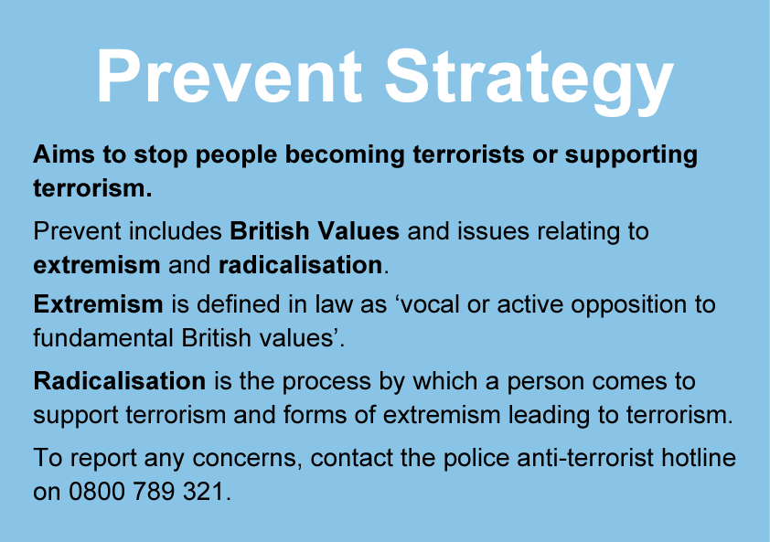

[www.gov.uk/ACT](http://www.gov.uk/ACT)