Vocational Profile

Name
Date
Employment Support Officer
People who have worked on this document

Index

Service Start Agreement | 3
Consent | 4
Section 1 – All About Me | 8
Section 2 – My Skills And Abilities | 13
Section 3 – Finding The Right Job For Me | 18
Section 4 – Job Matching | 23
Section 5 – In Work Support Examples | 30

Service Start Agreement

Please sign and date below to confirm you have started working with the Supported Employment Service

Date of conversation
Location of conversation
People involved in conversation (participant/ESO/circle of support)
People who have contributed

I confirm that I have now started working with the Supported Employment Service and am taking part in the support offered to me:

Name
Signature

Consent

So we can provide the best possible service to you, we may sometimes need to provide or obtain information relating to you from other people or organisations. This information will be kept private and this form will be reviewed every 3 months.

Permission to obtain or disclose information |  |  |  |  |  | YES | NO | Date
Support network (please include names)
Employers, training and education providers, basic skills providers
Adult Social Care, supported living staff or other social care providers
Employment services regarding my referral and progress
Date reviewed | Date reviewed | Date reviewed | Date reviewed | Date reviewed | Date reviewed | Date reviewed |  | Date reviewed

Name |  | Witnessed by
Location |  | Date
Disclosure Level

Sometimes it is helpful to tell an employer that you get support from an agency or that you have a disability. This is called disclosure. Sometimes, people don’t want their employer to know that they get support from an agency or that they have a disability.
You have the right to decide what level of disclosure you want. This is a very important decision. If your employer does not know that you have a disability, you are not covered by the Equality Act 2010.

Getting and keeping a job is not something we do for you. It’s something that we help you to do. People who succeed in work do so because they are motivated and want the job to be successful. W
We expect you to help yourself - our role is to support you in doing this. We want you to be as independent as possible and will only offer the least amount of support we think you need to be successful. Generally, we can offer three levels of support.
These are described on the next pages.

Level 1
Employer

We can contact your employer
If you choose this level of support, we can help you to get a job and even come with you to interviews if you wish us to. Once you are in work, we will be able to visit you in the workplace and support you, to learn the job and make progress. We will also make sure your supervisor and colleagues know about our support. Once you are working, we will keep in touch with you regularly and hold meetings where you can discuss how you are getting on.

Colleagues
We can contact your colleagues
_______________________________________________________________________________________________________________________________
Level 2

Employer
We can contact your employer
If you choose this level of support, we will contact your employer to support you in getting a job, but we will not contact your supervisor or colleagues in the workplace. We will have regular reviews with you along with a supervisor from your workplace that you choose.
Colleagues

We will not contact your colleagues
Level 3

Employer
We will not contact your employer
If you choose not to tell your employer or your work colleagues about the support you receive from us, we will only give you limited support outside of work. We will have no contact with your employer and will not be able to approach them for you. Remember: if your employer does not know that you have a disability, you are not covered by the Disability Discrimination Act. This is a very important decision,
Colleagues

We will not contact your colleagues

Level of disclosure selected
Name of client |  | Signature
Name of significant other  (if appropriate) |  | Signature of significant other
Employment Support Officer |  | Date

Section 1 – All About Me

Do you have the following? | YES | NO | Action
Picture proof of identification
A bank account in your name
Proof of your right to work in the UK

Tell me about your support network - family, friends etc. Who do you live with? What support do you have? For example, social worker, appointee (include contact details)
Do you have any caring responsibilities? If yes, how might this affect your work?

Please tell us about your health conditions. Include information about disabilities and allergies.
How does your health and disability affect you?
Personal | Other | Source | Date
What medication do you take? How will this affect you at work?
Are there any habits or behaviours that we need to be aware of? What might trigger these?
Personal | Other | Source | Date

ADD IN RELIGIOUS BELIEFS SECTION
Do you have any cultural or religious beliefs we need to consider?



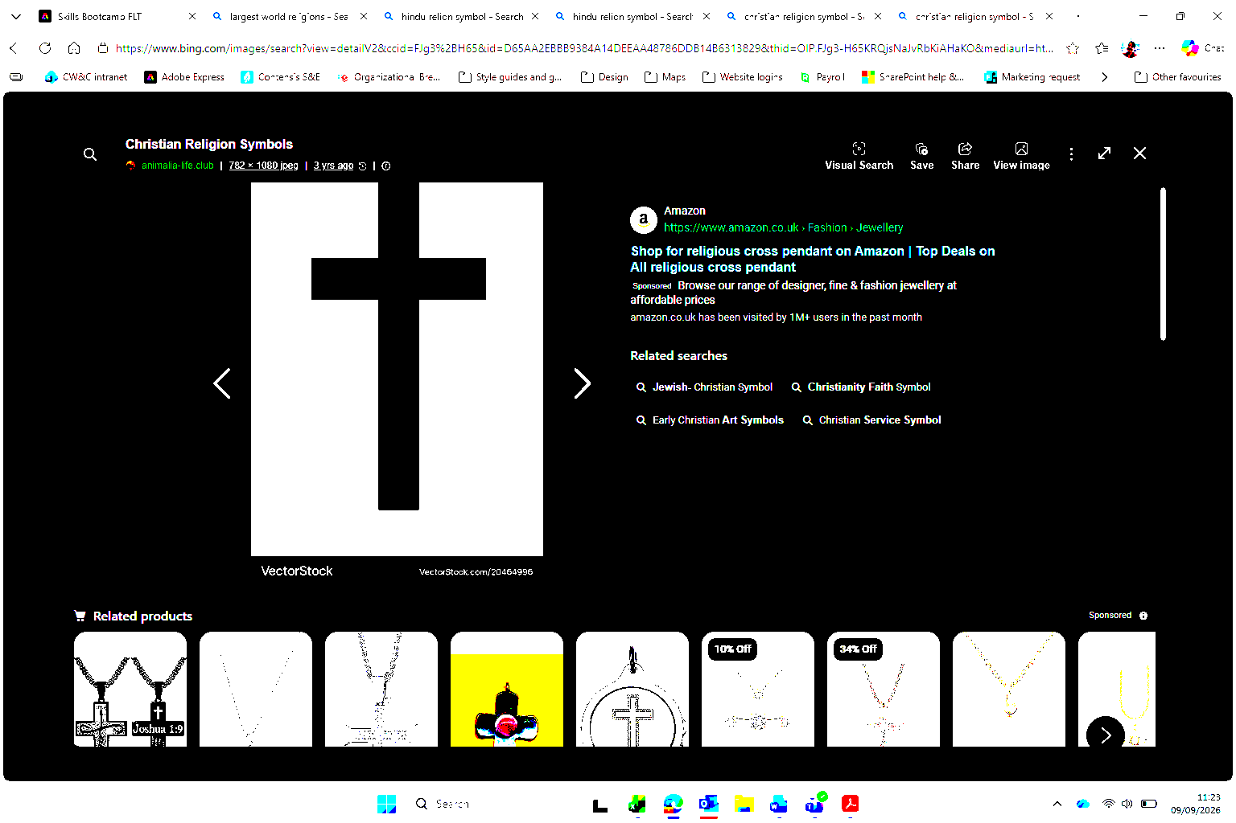
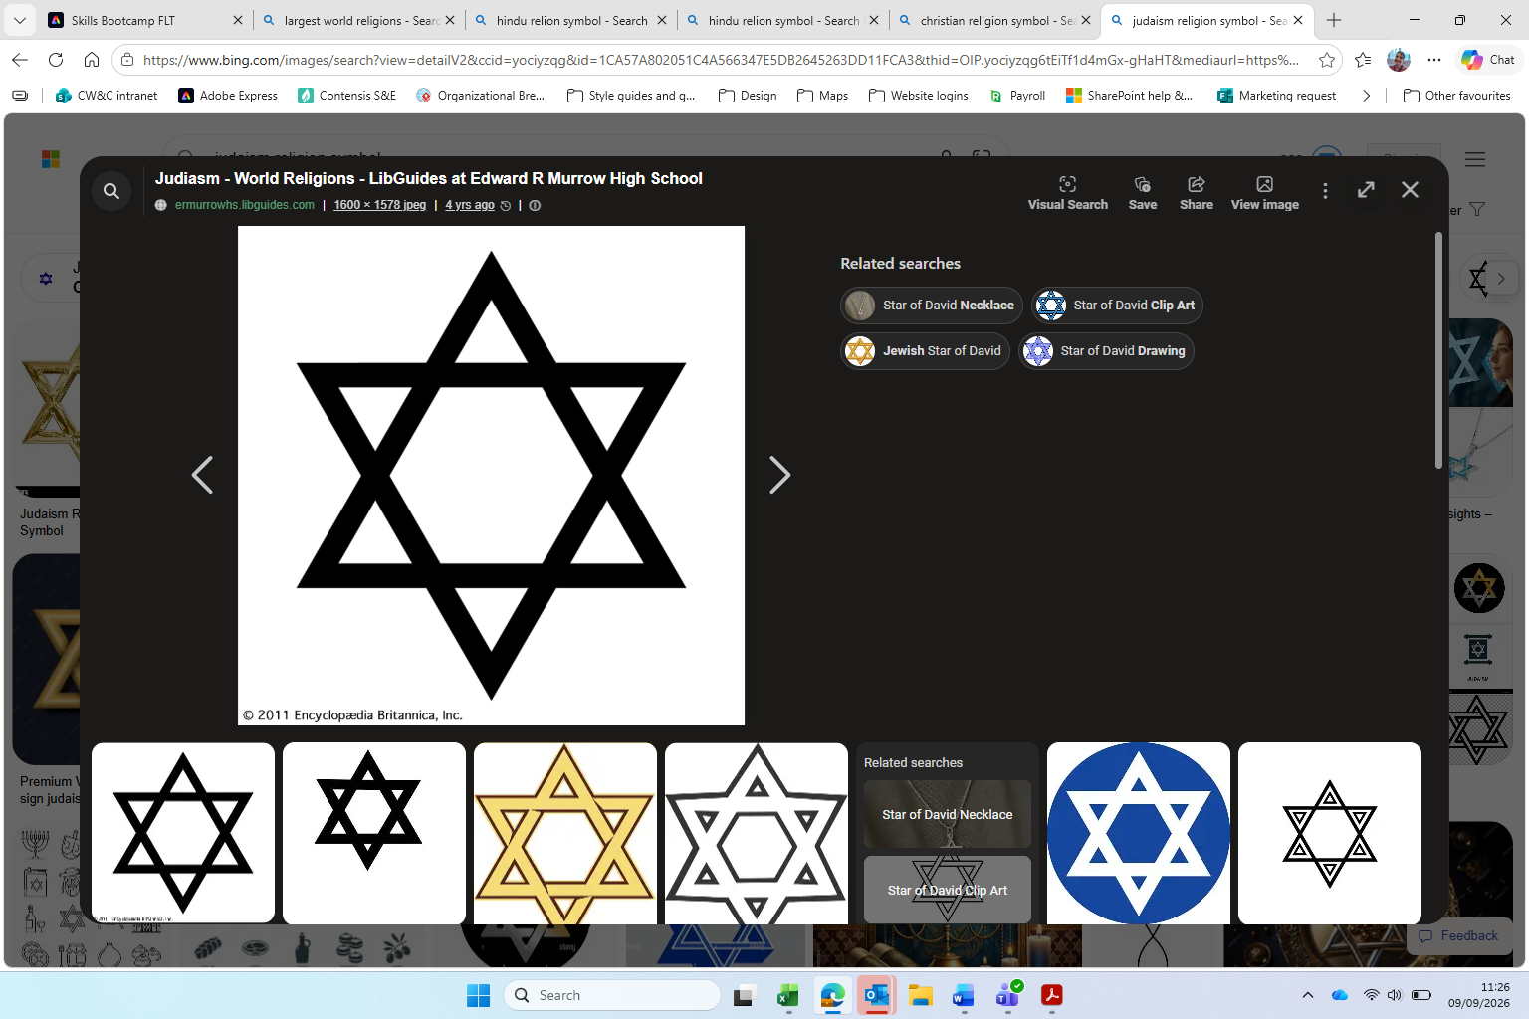
Tell me about your hobbies and interests






What do you do in a typical week? Tell us about any support, day service, activities, volunteering etc

Day |   Morning |   Afternoon |   Evening
Monday
Tuesday
Wednesday
Thursday
Friday

What education, qualifications and training have you have completed




Name of school, college attended | Course and qualification | Date
Any other information

Section 2 – My Skills and Abilities
Skills | Strength | Support needed? | Examples – Skills observed, actions

Verbal and written communication

Mathematical ability

Teamwork
  Telephone skills | 

IT skills

Following instructions

Time keeping and
telling the time

Money handling and recognising coins

Problem-solving

Keeping on task

Attention to detail

Listening skills
Social skills – for
example, face to face

Memory

Tell us any feedback you have had from placements, employers and your support network

Physical demands |  | Support needed? |  |  | Comments
 |  | YES | NO | N/A | Comments
Lifting and stooping | 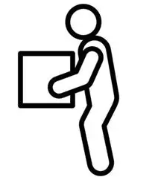
Standing – including for  long periods | 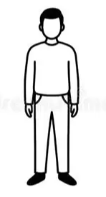
Continuous movement | 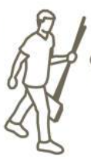
Rapid movement | 
Walking and running | 
Climbing and heights | 
Dexterity - using hands | 
Crawling | 
Pushing and pulling | 
Working at speed | 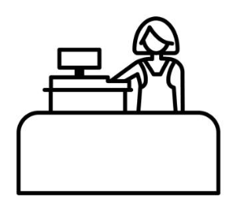

Sensory and communication abilities |  | Support needed? |  |  | Comments
 |  | YES | NO | N/A | Comments
Vision – including lights | 
Hearing – including noise
Speaking | 
Initiative | 
Judgement | 

Tell us any feedback you have had from placements, employers and your support network

Section 3 – Finding The Right Job For Me

What motivates you to work? Why do you want a job?


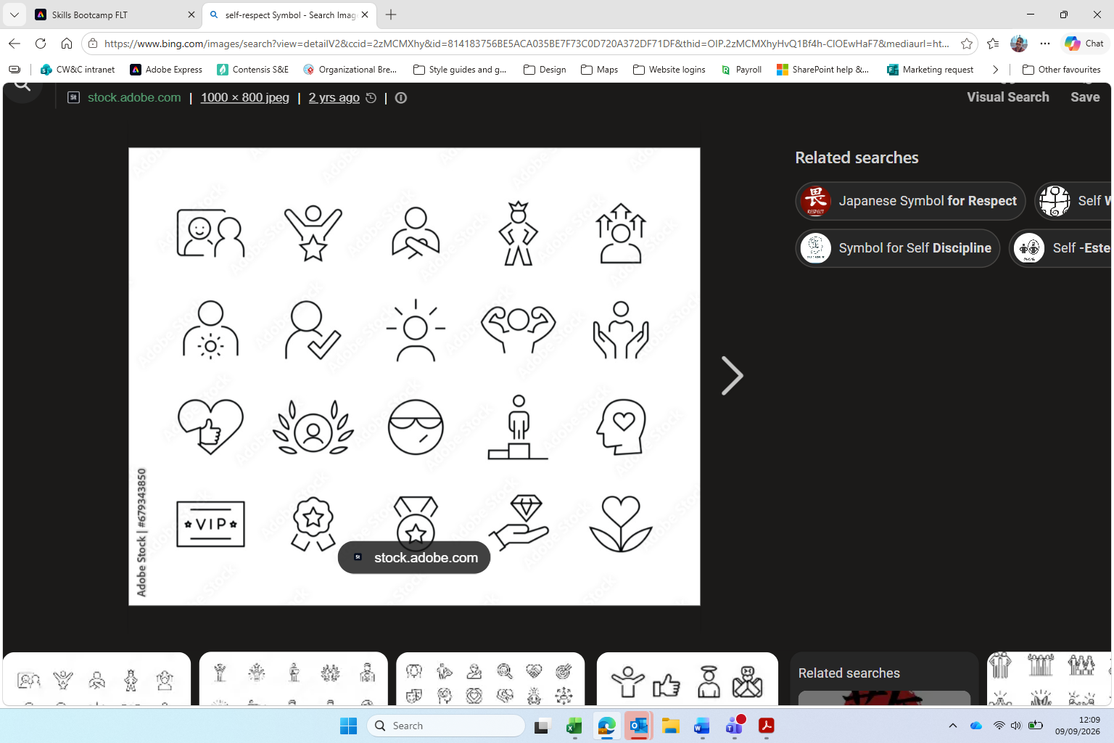
Tell me about your previous work experience
What feedback have you had from previous employers or from any voluntary work?
Personal | Other

Working hours
What hours would you like to work?
Full time – 36 or more hours, usually 5 days a week |  | Part time – under 36 hours per week |  | How many hours would you prefer?
Nights – shifts between 7pm and 7am |  | Casual or flexible working

When are you available? | Morning | Afternoon | Evening | Night
Monday
Tuesday
Wednesday
Thursday
Friday
Saturday
Sunday

Would you consider working in shifts? This is a varied work pattern. There are some examples below.
Early (6am-2pm) |  | Day (9am-5pm) |  | Afternoons  (2-10pm) |  | Late (6-10pm) |  | Rotating

Travel
Can you travel independently? | YES |  | NO

Can you travel by…? | YES | NO | With support | Without support
Bus
Train
Tram
Bike
Can you drive?

Do you have a bus pass? (tick box) | YES |  | NO |  | Not applicable
How will you travel to work?
What help or training is needed?

Money
 | YES | NO | Comments
Do you have an appointee?
Do you receive benefits?
Which benefits do you receive?
Do you require benefit support?

You can look at the following websites to see if you could earn more money by having a job. This is called a “better off in work” calculation.
 | Turn2us Benefits Calculator
 | Entitledto Benefits Calculator
 | Cheshire West and Chester Council Benefits Calculator

Section 4 – Job Matching

What sort of work would you like to do?
Health and social care | Manufacturing | Retail and sales | Customer service
 |  |  | 
Where you might work:  Hospital, daycare centre, nursery, childcare  What you might do:  Care work | Where you might work:  Factory, warehouse  What you might do: Assembly line | Where you might work:  Shop, supermarket, garden centre  What you might do:  Using the till, restocking shelves, serving customers | Where you might work:  Shop, supermarket, call centre, hairdresser, beauty salon, car garage, petrol station, theatre, cinema  What you might do:  Serving customers

Admin and computing | Hospitality and food | Maintenance services | Horticulture
 |  |  | 
Where you might work:  Office  What you might do:  Reception, customer service, using computers, software development, editing media | Where you might work:  Café, restaurant, fast food outlet, pub, hotel  What you might do:  Clearing tables, preparing food | Where you might work:  Office, café, hotel, shop  What you might do:  Cleaning and housekeeping, waste and recycling, car washing | Where you might work:  Garden Centre, gardens, farm  What you might to:  Gardening, farming

Travel and tourism | Sport and leisure | Construction | Teaching and education
 |  |  | 
Where you might work:  Hotel, outdoor events  What you might do:  Catering | Where you might work :  Leisure centre, gym, kennels, stables, outdoor events  What you might to:  Customer service, catering, dog walking | Where you might work:  Building site  What you might do:  Labouring, engineering | Where you might work:  School, college  What you might do:  Teaching assistant, catering

Are there any other places of work you would like to explore?

What kind of working environment would you prefer?
Indoors |  | Mainly alone |  | In one place |  | In a busy workplace
Outdoors |  | With other people |  | Repetitive tasks |  | Using equipment

Additional information
What type of job do you think is most suited to you? Write your job ideas here.
Why do you think the job(s) would suit you?
Would you be interested in being self-employed? | YES |  | NO

Please tell us about any concerns or fears you have about getting a job or working

What jobs do people do in Cheshire West and Chester? This is called “labour market information”.

Most jobs |  | Fewest jobs |  | Growth sectors
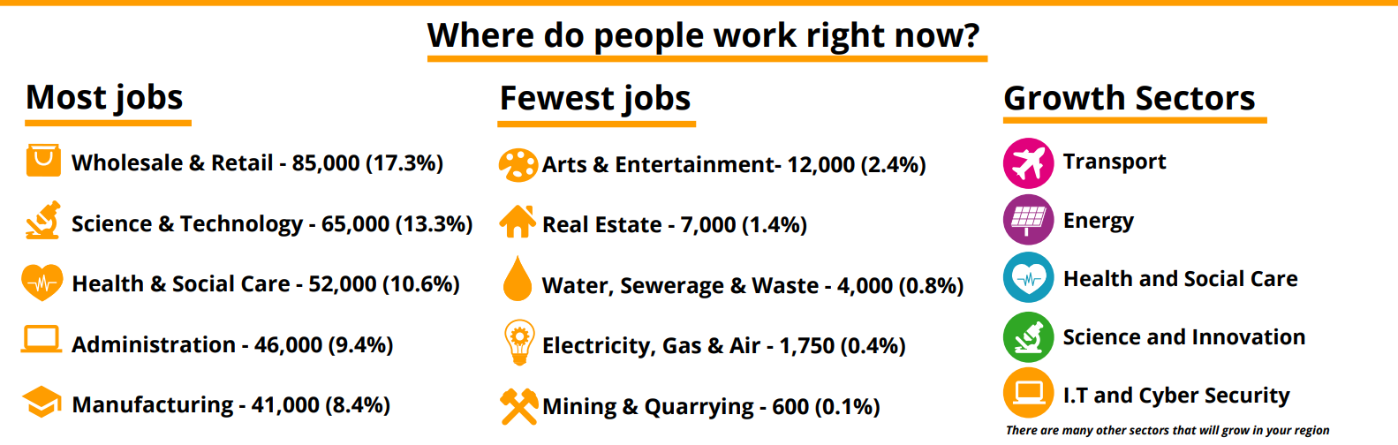 | Wholesale and retail  85,000 (17%) |  | Arts and entertainment  12,000 (2%) |  | Transport
 | Science and technology  65,000 (13%) |  | Estate agents  7,000 (1%) |  | Energy
 | Health and social care  52,000 (11%) |  | Water, sewerage and waste  4,000 (<1%) |  | Health and social care
 | Administration  46,000 (9%) |  | Electricity, gas and air  1,750 (<1%) |  | Science and innovation
 | Manufacturing  41,000 (8%) |  | Mining and quarrying  600 (<1%) |  | IT and cybersecurity

Most frequently advertised jobs in Cheshire West and Chester 2024-2025
Job role | Number of jobs advertised
Care workers and home carers | 4307
Cleaners and domestics | 3059
Sales related occupations | 2892
Kitchen and catering assistants | 2408
Sales and retail assistants | 2428
Customer service occupations | 1837
Managers and directors in retail and wholesale | 1162
Chefs | 1109
Bar staff | 871
Teaching assistants | 952

Section 4 – In Work Support Examples

Please tell us about any support you might need with work
 | YES | NO | Additional information and feedback
It would help me to visit my workplace before starting
I would like a plan, schedule of work or list of tasks I am expected to do each day or week
I would like to meet my manager before starting my job
I would like from seeing where I am going to sit and where I can have my lunch.
It would help me to know the address of my workplace so that I can practise my journey
It would help me to know what I should wear to work
Other – please add details

Instructions and tasks. Tell us what would help you do your work once you start.
 | YES | NO | Additional information and feedback
I like instructions in writing
I like information presented with pictures, flow charts and diagrams
I like to write down instructions, to help me remember what to do
I prefer one question or instruction at a time
If I am given instructions, I like to be told during an arranged meeting, rather than when I am doing something else
It helps me to have some time to process what you have said
I prefer to do something else while listening, for example, use a fidget toy
I like to have information or questions in advance before discussing them
I prefer to concentrate on one task at a time
I am comfortable completing the same task over and over again
I prefer to have variety in the tasks I am doing
It is helpful for me to know in advance if anything is changing so I can get used to anything new
I prefer to structure my daily tasks, including breaks
I may need some extra time to complete tasks and have some freedom in when things need to be done by

Adjustments and adaptations that can be considered | Additional information and feedback
Assistive technology
Training
Visual guides
Job carving
Reasonable adjustments
Work trial or work experience
Job coach

Access To Work to be considered?
Any additional information

