Learner Agreement – Using AI responsibly
Most recent update 08 April 2026

We want you to be able to use AI tools as part of your learning. AI can be used to generate ideas, check your understanding or explore new topics. However AI must be used carefully as it can cause problems.

Good use of AI

Support your learning
Use AI to help you understand your work and get ideas.

Be honest
Tell your tutor if AI helped you.

Think carefully
Always check information from AI. AI can get things wrong.

Use approved tools
Only use AI tools allowed by your centre.

Not allowed

Plagiarism
Do not hand in work written by AI and say it is your own.

Cheating
Do not use AI for exams or assessments.

Skipping the learning
AI must not do the thinking for you.

Inappropriate content
Do not create harmful or rude contact using AI.

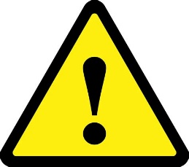
If you misuse AI
You may need to redo your work and you may lose access to AI.

Learner Declaration
Please read the following declaration and sign to confirm your agreement.

Learner name:
Course/activity:
AI Tool Used: | AI Tool Used: [e.g. Grammarly, Copilot etc] ____________________________
Purpose: | [How did AI help with your work?]
Attached Evidence: | [Screenshots or records of AI-generated content and prompts]
Date of Use:
Please tick the boxes below to confirm:
This work is my own |  | ☐
I have followed the centre’s rules for using AI |  | ☐
I have not used AI to write or change large parts of my work |  | ☐
I have not used AI generated content without saying so |  | ☐
I have not used AI to avoid doing my own learning |  | ☐
I read the guidelines and only used tutor-approved AI tools |  | ☐
I understand that misuse of AI can lead to penalties |  | ☐

Learner name (block capitals) ____________________________________________

Learner signature ____________________________________________

Date ____________________________________________

Some content and resources used in the development of this material were created with support from Microsoft Copilot, an AI tool. All content has been reviewed and adapted by education professionals to ensure accuracy, relevance and suitability for learners, 20 August 2025.

