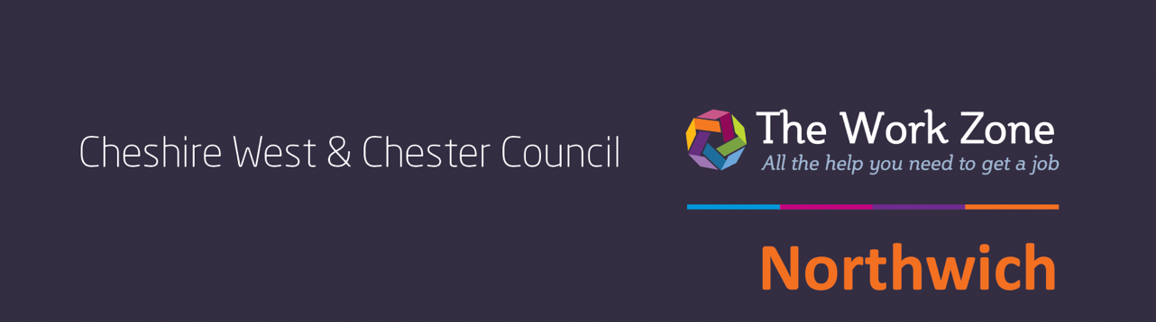
FREE COURSE
This course will be free for most learners. Please contact us for more eligibility details
Provider name here





Provider logo
Course name
Summary line

Details of course topics to be covered. Details of course topics to be covered. Details of course topics to be covered. Details of course topics to be covered.
Details of course topics to be covered.

Every weekday morning
1-5 January 2025 9.30am – 1.30pm at
Address 1
Address 2
Address 3
Postcode
To book your place please contact
0XXXX XXXXXX or
emailaddress@
providername.com

