Certificate of achievement
This is to certify that | [learner name]
Has completed the programme | [course title]
Presented by | [tutor, department or provider]
Signature
Date
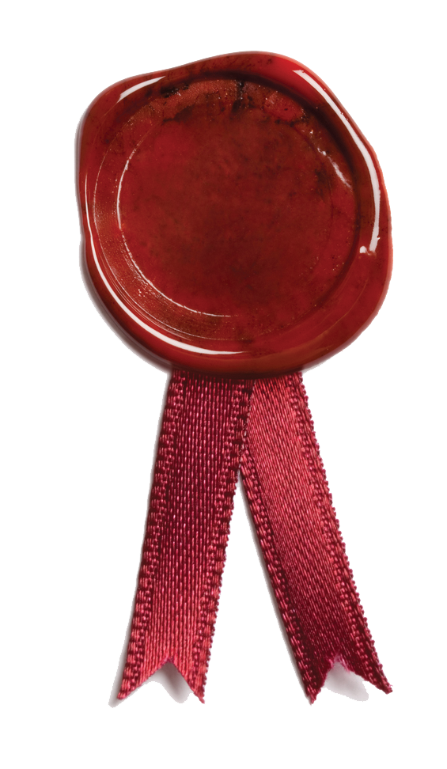
Certificate of achievement – Certificate of achievement – Certificate of achievement – Certificate of achievement – Certificate of achievement – Certificate of achievement – Certificate of achievement – Certificate of achievement – Certificate of achievement – Certificate of achievement – Certificate of achievement – Certificate of achievement – Certificate of achievement – Certificate of achievement – Certificate of achievement – Certificate of achievement – Certificate of achievement – Certificate of achievement – Certificate of achievement – Certificate of achievement – Certificate of achievement – Certificate of achievement – Certificate of achievement – Certificate of achievement – Certificate of achievement – Certificate of achievement – Certificate of achievement – Certificate of achievement – Certificate of achievement – Certificate of achievement – Certificate of achievement – Certificate of achievement – Certificate of achievement – Certificate of achievement – Certificate of achievement – Certificate of achievement – Certificate of achievement – Certificate of achievement – Certificate of achievement – Certificate of achievement – Certificate of achievement – Certificate of achievement – Certificate of achievement – Certificate of achievement – Certificate of achievement – Certificate of achievement – Certificate of achievement – Certificate of achievement – Certificate of achievement – Certificate of achievement – Certificate of achievement – Certificate of achievement – Certificate of achievement – Certificate of achievement – Certificate of achievement – Certificate of achievement – Certificate of achievement – Certificate of achievement – Certificate of achievement – Certificate of achievement – Certificate of achievement – Certificate of achievement – Certificate of achievement – Certificate of achievement – Certificate of achievement – Certificate of achievement – Certificate of achievement – Certificate of achievement – Certificate of achievement – Certificate of achievement – Certificate of achievement – Certificate of achievement – Certificate of achievement – Certificate of achievement – Certificate of achievement – Certificate of achievement – Certificate of achievement – Certificate of achievement – Certificate of achievement – Certificate of achievement – Certificate of achievement – Certificate of achievement – Certificate of achievement – Certificate of achievement – Certificate of achievement – Certificate of achievement – Certificate of achievement – Certificate of achievement – Certificate of achievement – Certificate of achievement – Certificate of achievement – Certificate of achievement – Certificate of achievement – Certificate of achievement – Certificate of achievement – Certificate of achievement – Certificate of achievement – Certificate of achievement – Certificate of achievement – Certificate of achievement – Certificate of achievement – Certificate of achievement – Certificate of achievement – Certificate of achievement – Certificate of achievement – Certificate of achievement – Certificate of achievement – Certificate of achievement – Certificate of achievement – Certificate of achievement – Certificate of achievement – Certificate of achievement – Certificate of achievement – Certificate of achievement – Certificate of achievement – Certificate of achievement – Certificate of achievement –

